ASSISTED PRACTICE-3

INTRODUCTION TO CLOUD,EC2,S3 BUCKET AND EBS VOLUME

LAUNCH THE AWS LAB AND CLICK LAUNCH INSTANCE

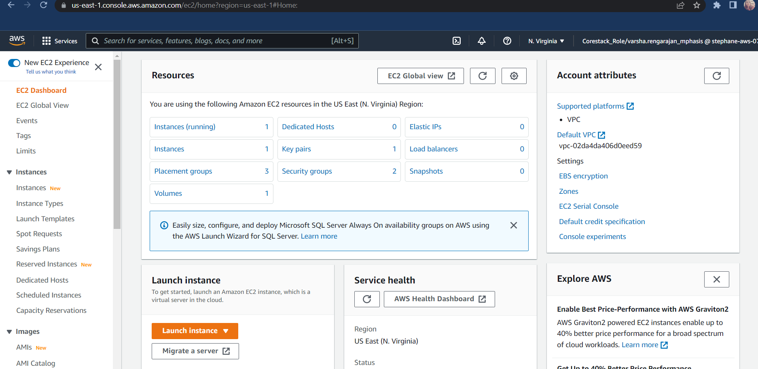

MOST OF THE OPTIONS WILL BE DEFAULT ENTER THE CLICK “ADD ANOTHER TAG” ADD KEY = LINUX  AND VALUE =FIRSTLINUX CLICK “CONFIGURE SECURITY GROUP” AND NOW SELECT HTTP AND CLICK LAUNCH

THE POP-UP WILL COME IN WHICH YOU CAN   
1 SELECT THE “CREATE A NEW KEY PAIR”  
2 ENTER KEY PAIR NAME (IT IS USER DEFINED)  
3 CLICK “DOWNLOAD KEY PAIR”  (TO DOWNLOAD THE KEY IN THE SYSTEM)  
4 CLICK “LAUNCH INSTANCES”

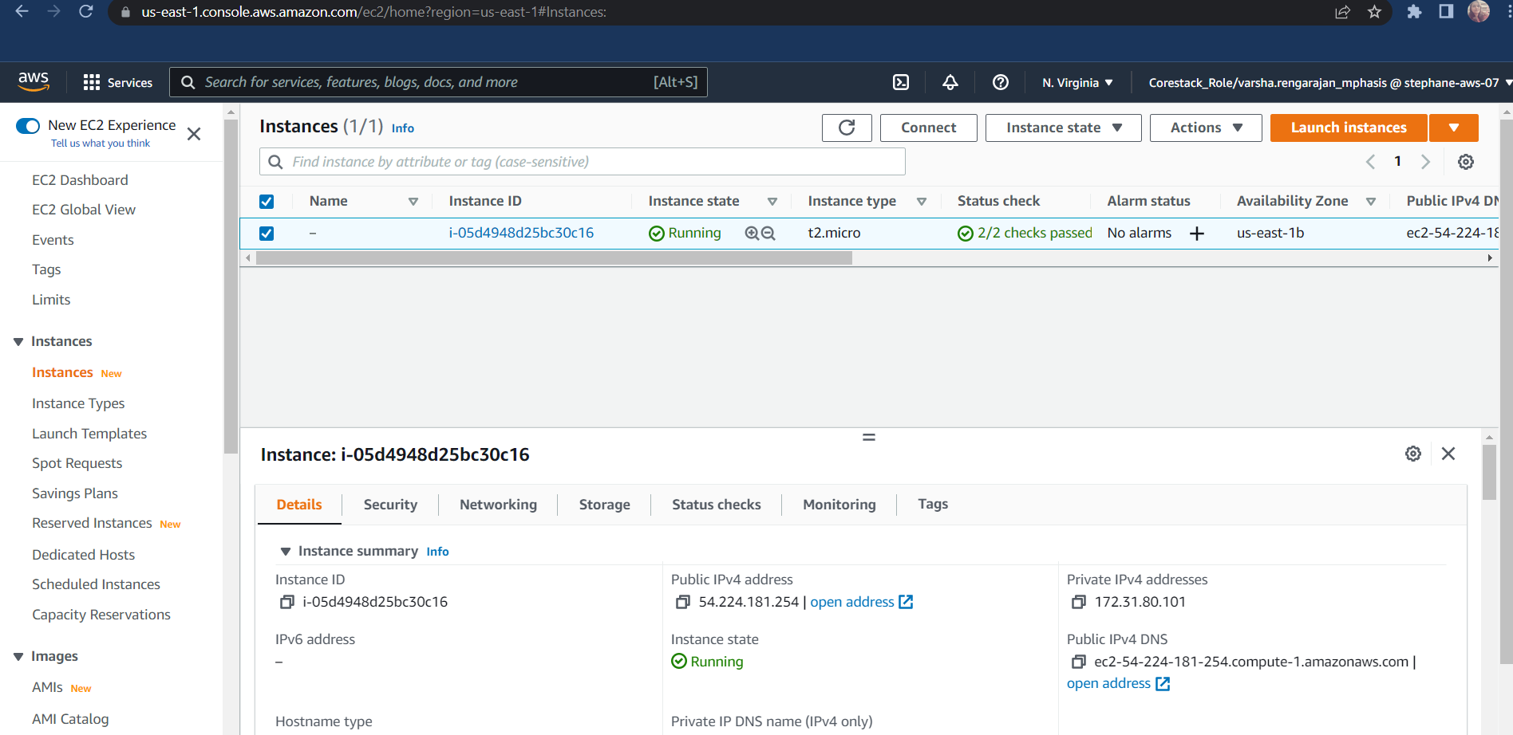  
NOTE THE INSTANCE ID AND AVAILABILITY ZONE SEPARATELY

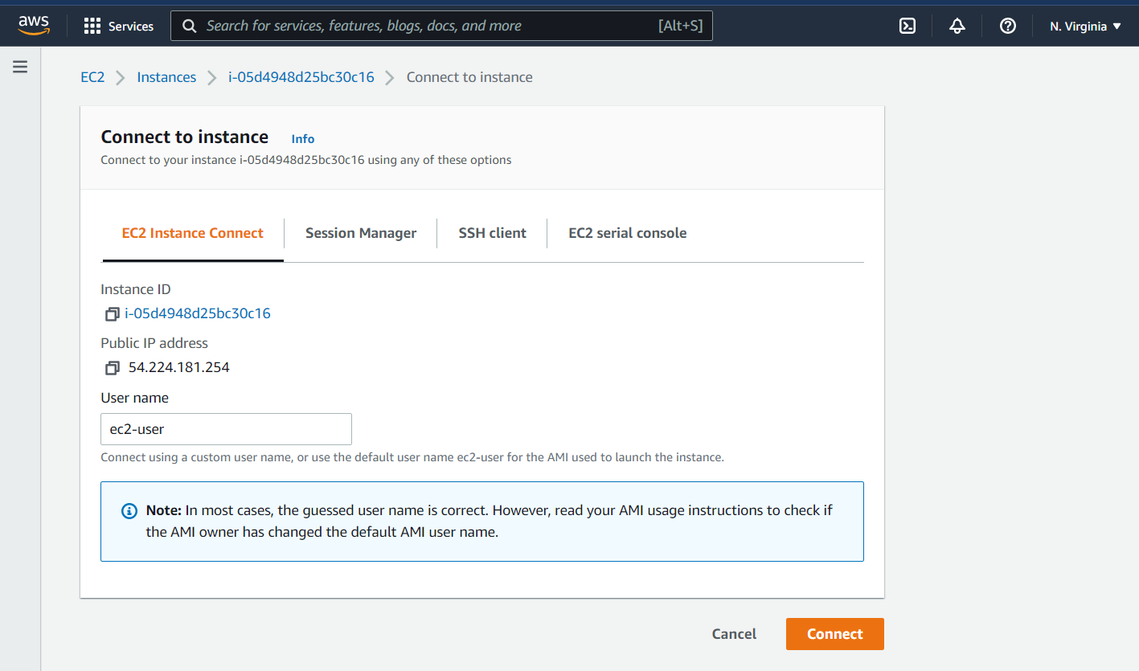NOW CLICK THAT INSTANCE AND PRESS CONNECT

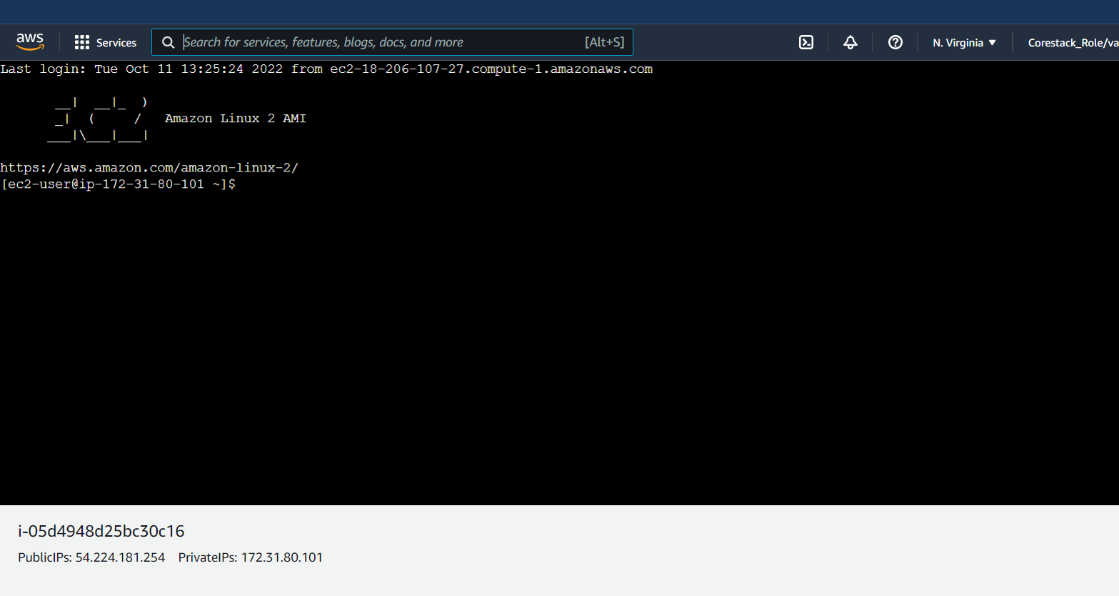A LINUX PAGE WILL BE OPENED

CHANGE THE VOLUME SIZE OF INSTANCE

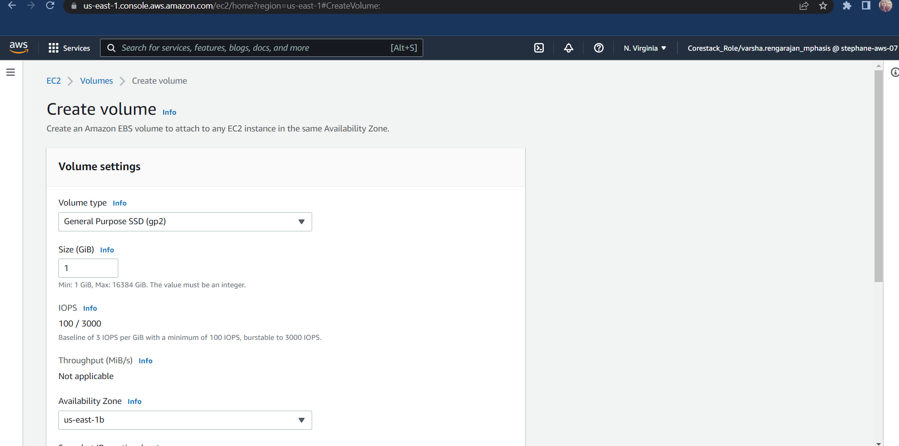

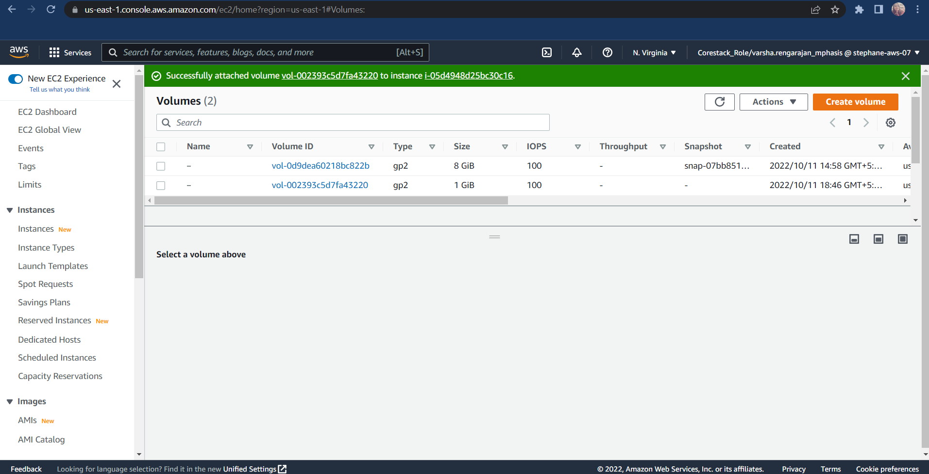

MOUNT THE VOLUME INSTANCE

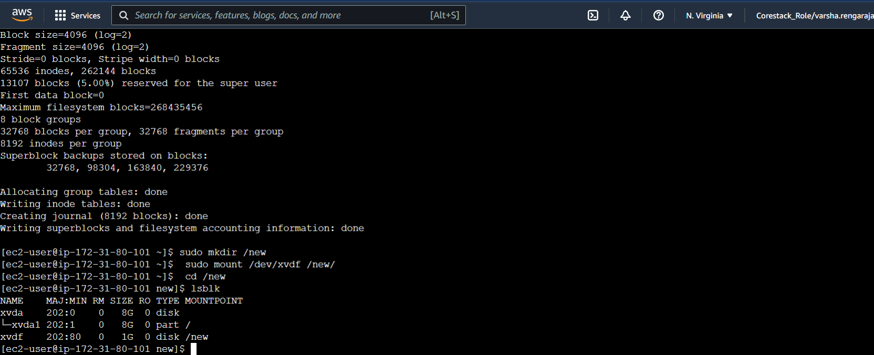

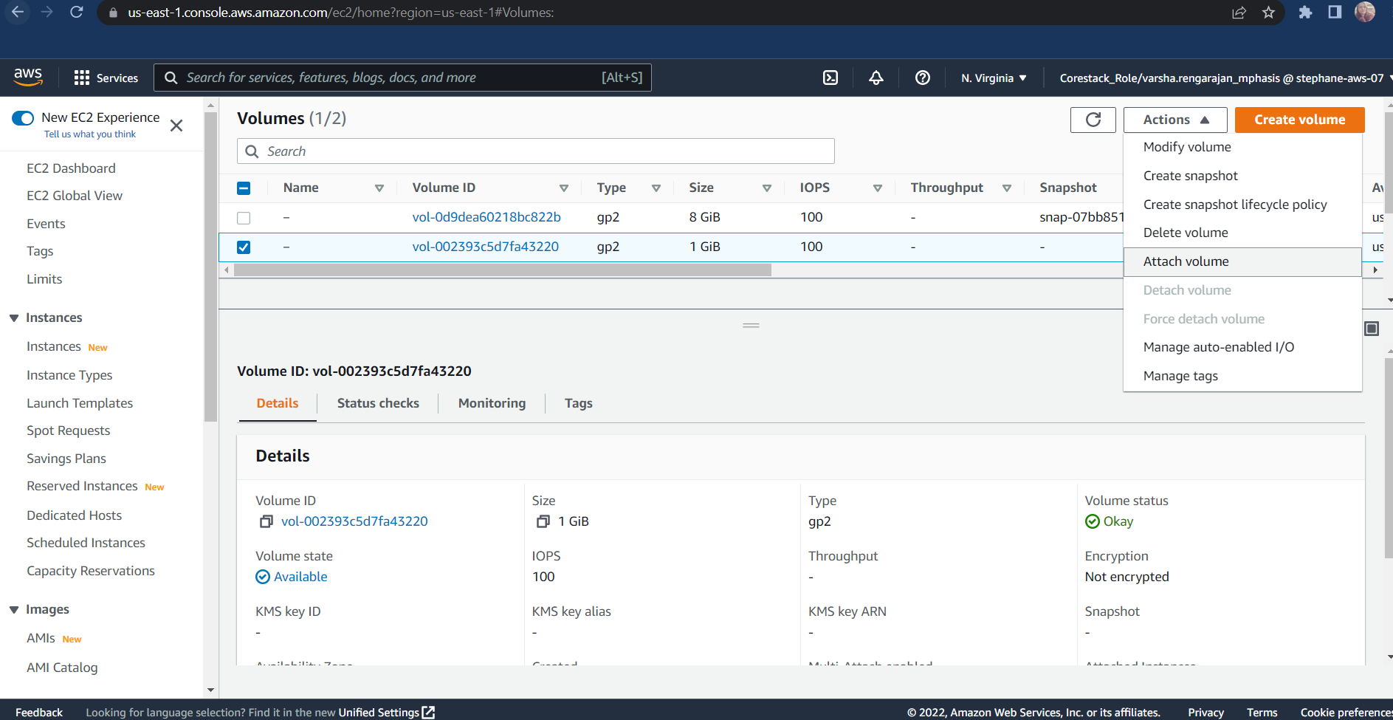ATTACH THE VOLUME INSTANCE

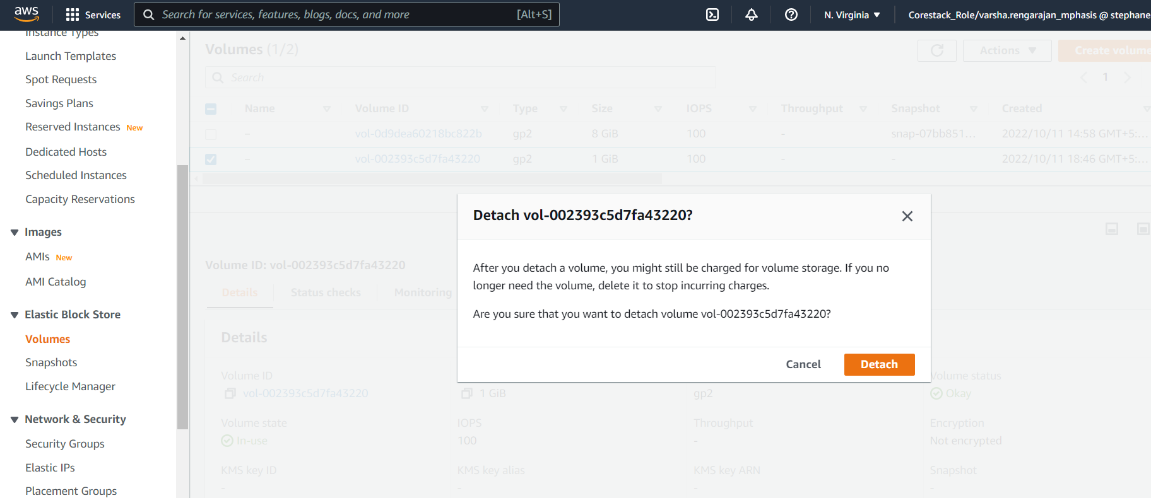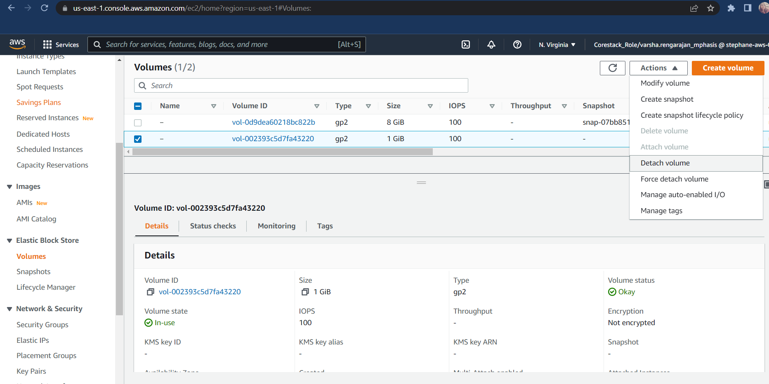DETACH THE VOLUME INSTANCE

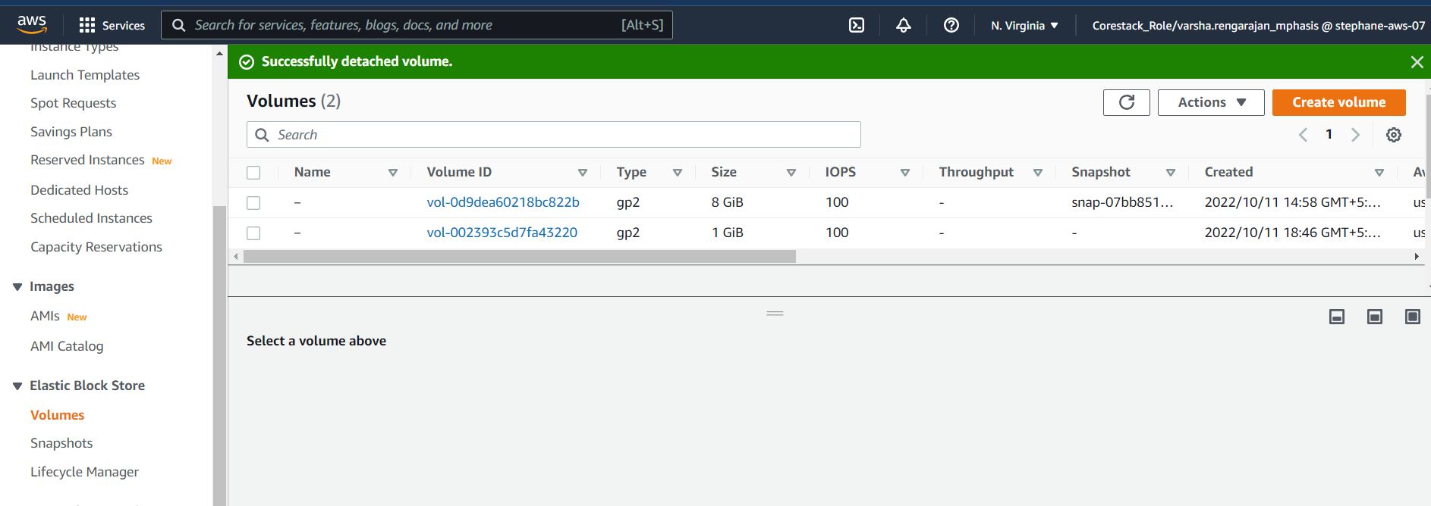

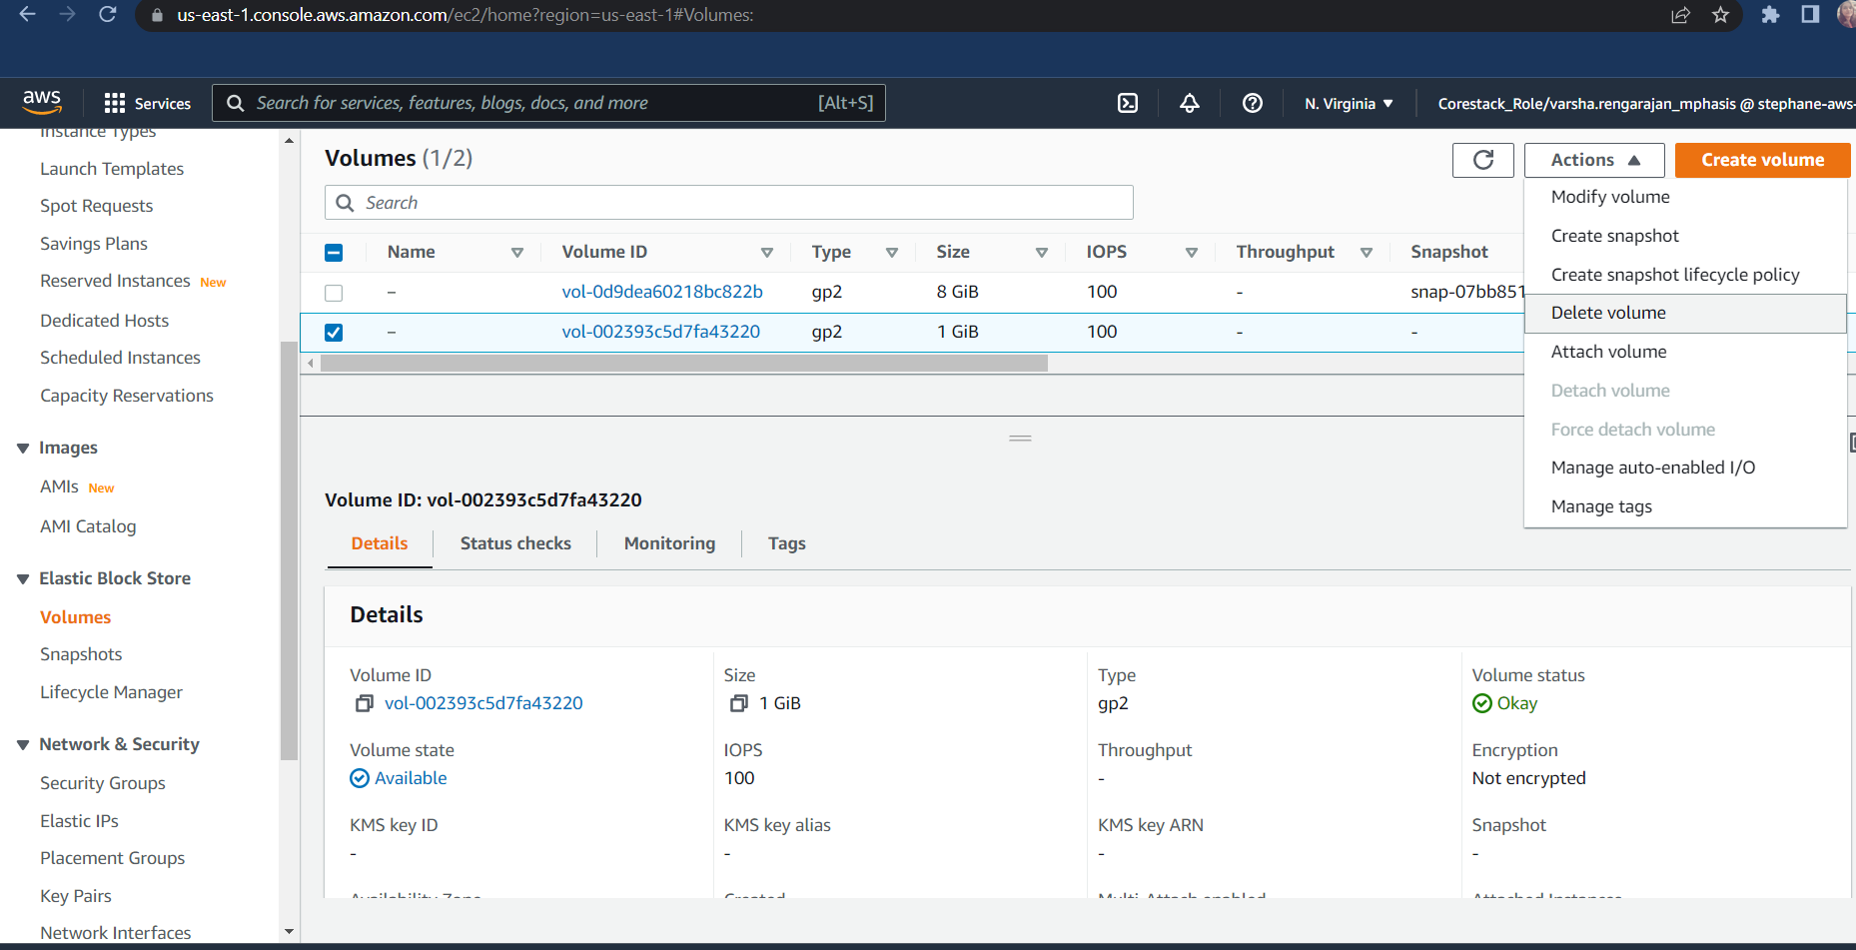DELETE A VOLUME INSTANCE

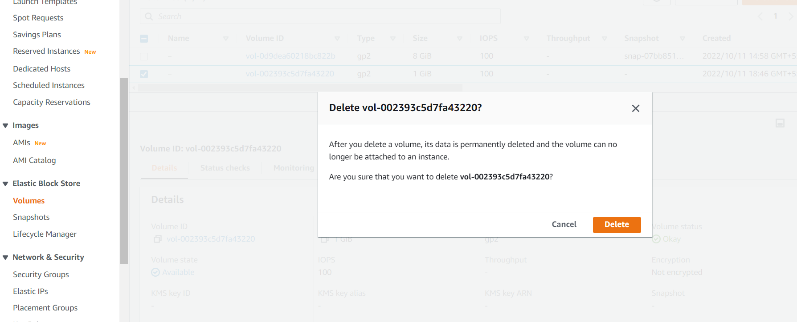

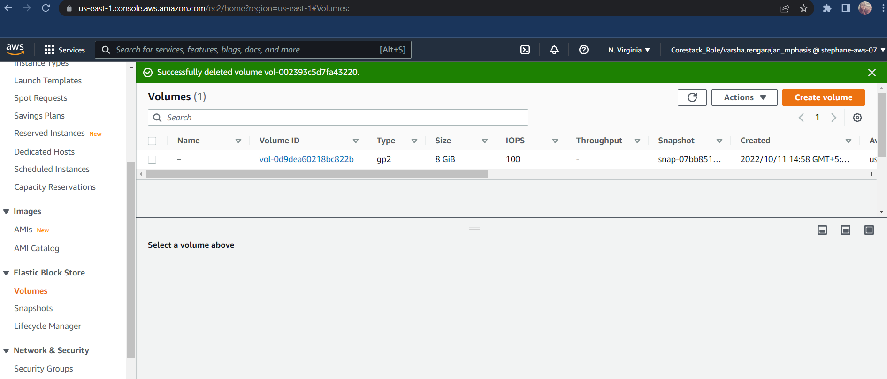CREATE A PLACEMENT GROUP

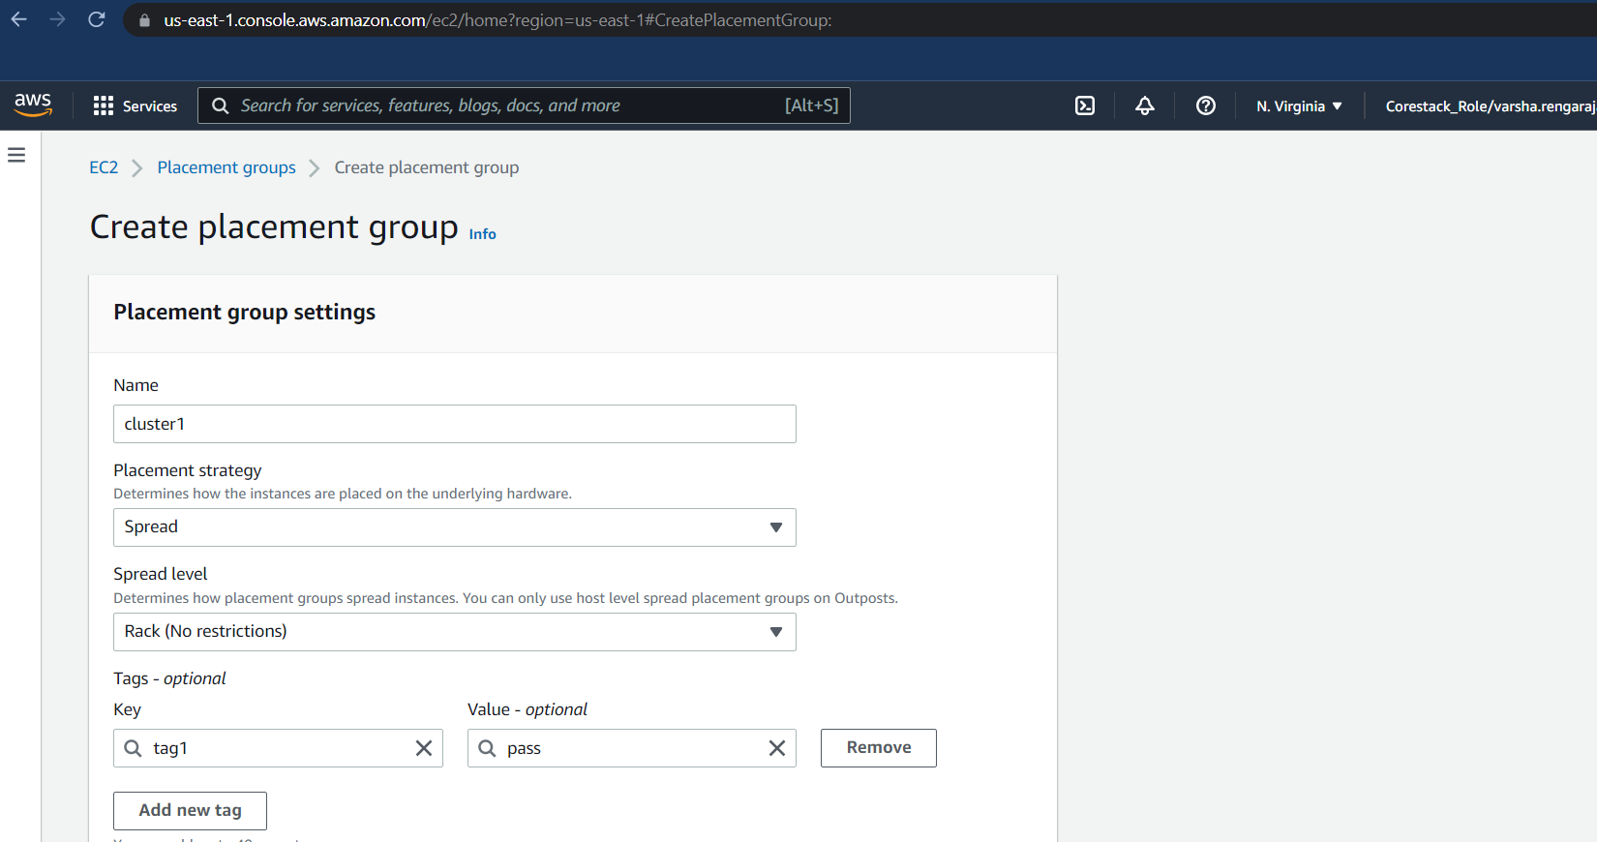

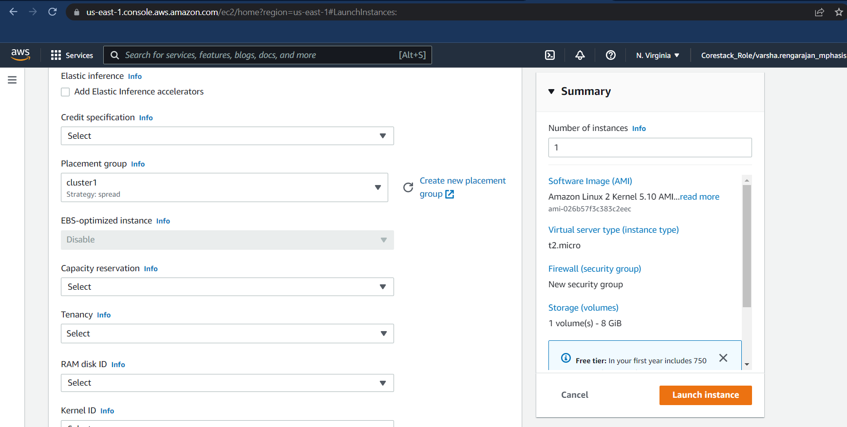

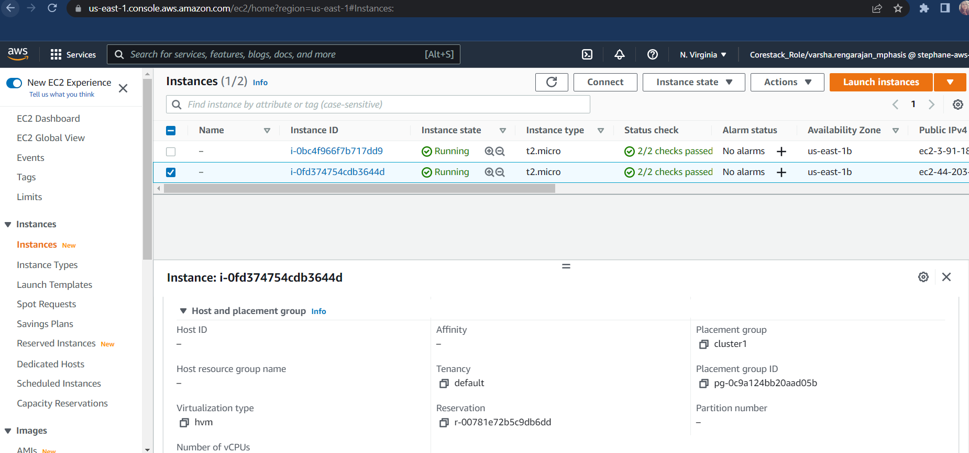

CRAETE SECURITY GROUPS

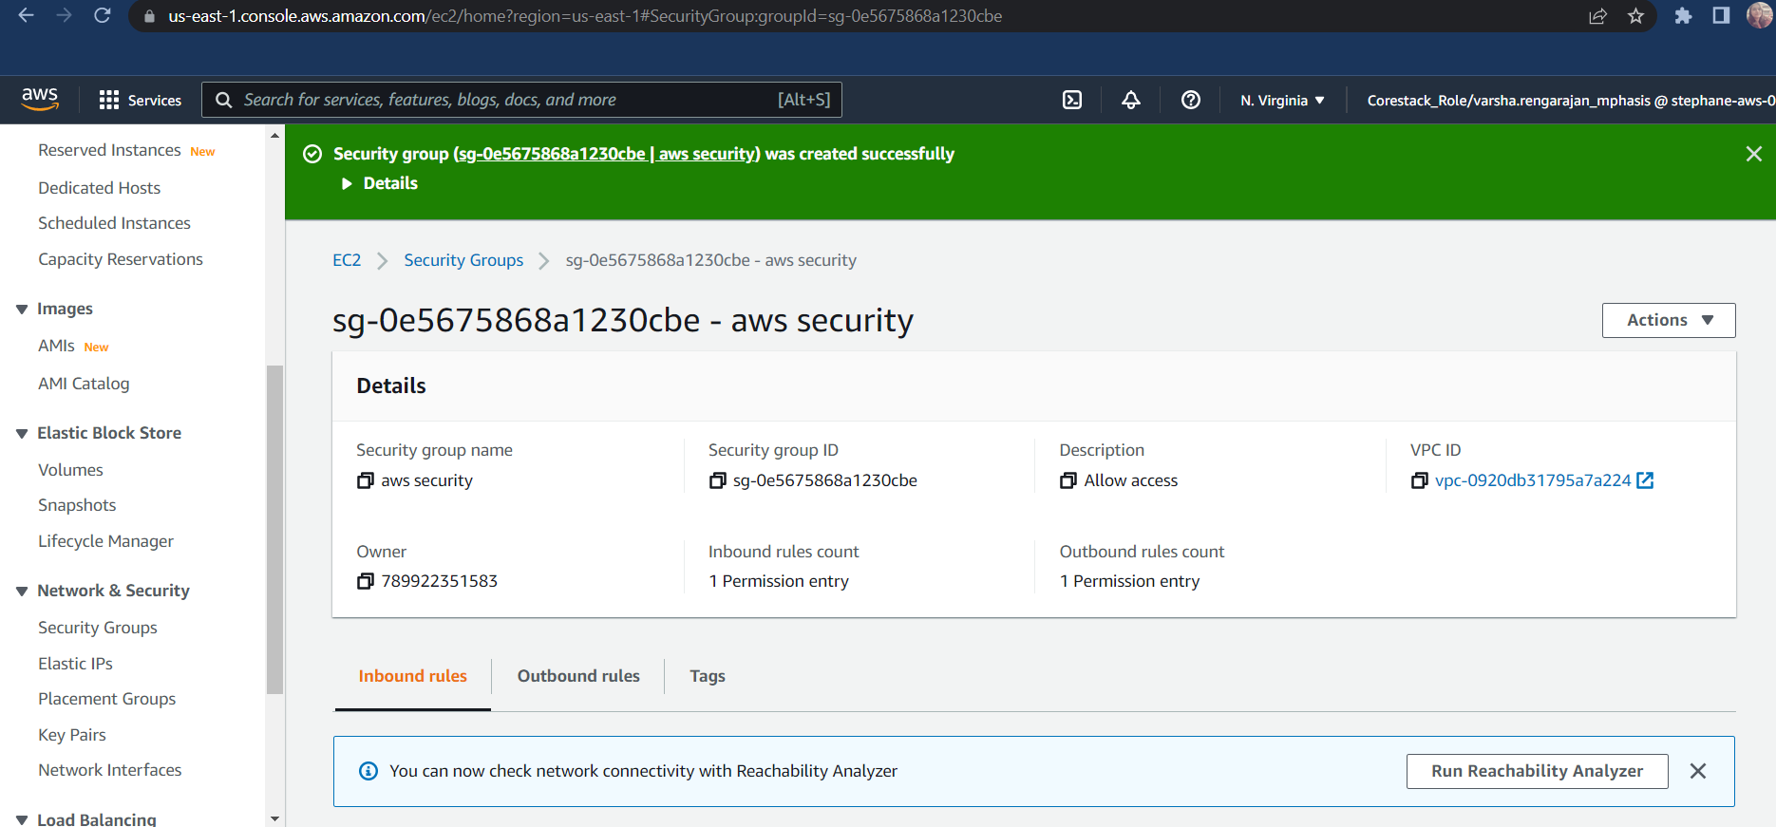

CREATION OF S3 BUCKET

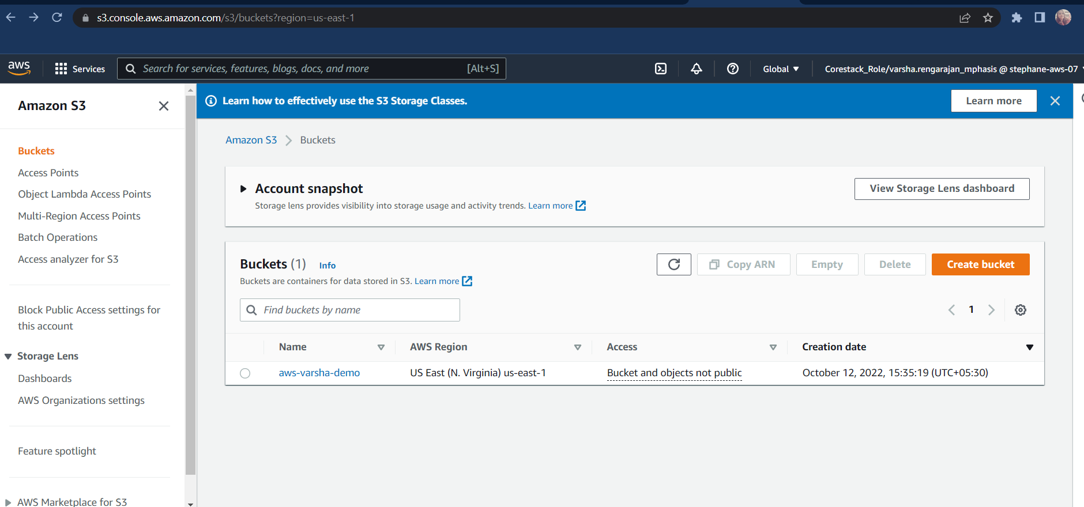

STORAGE CLASS

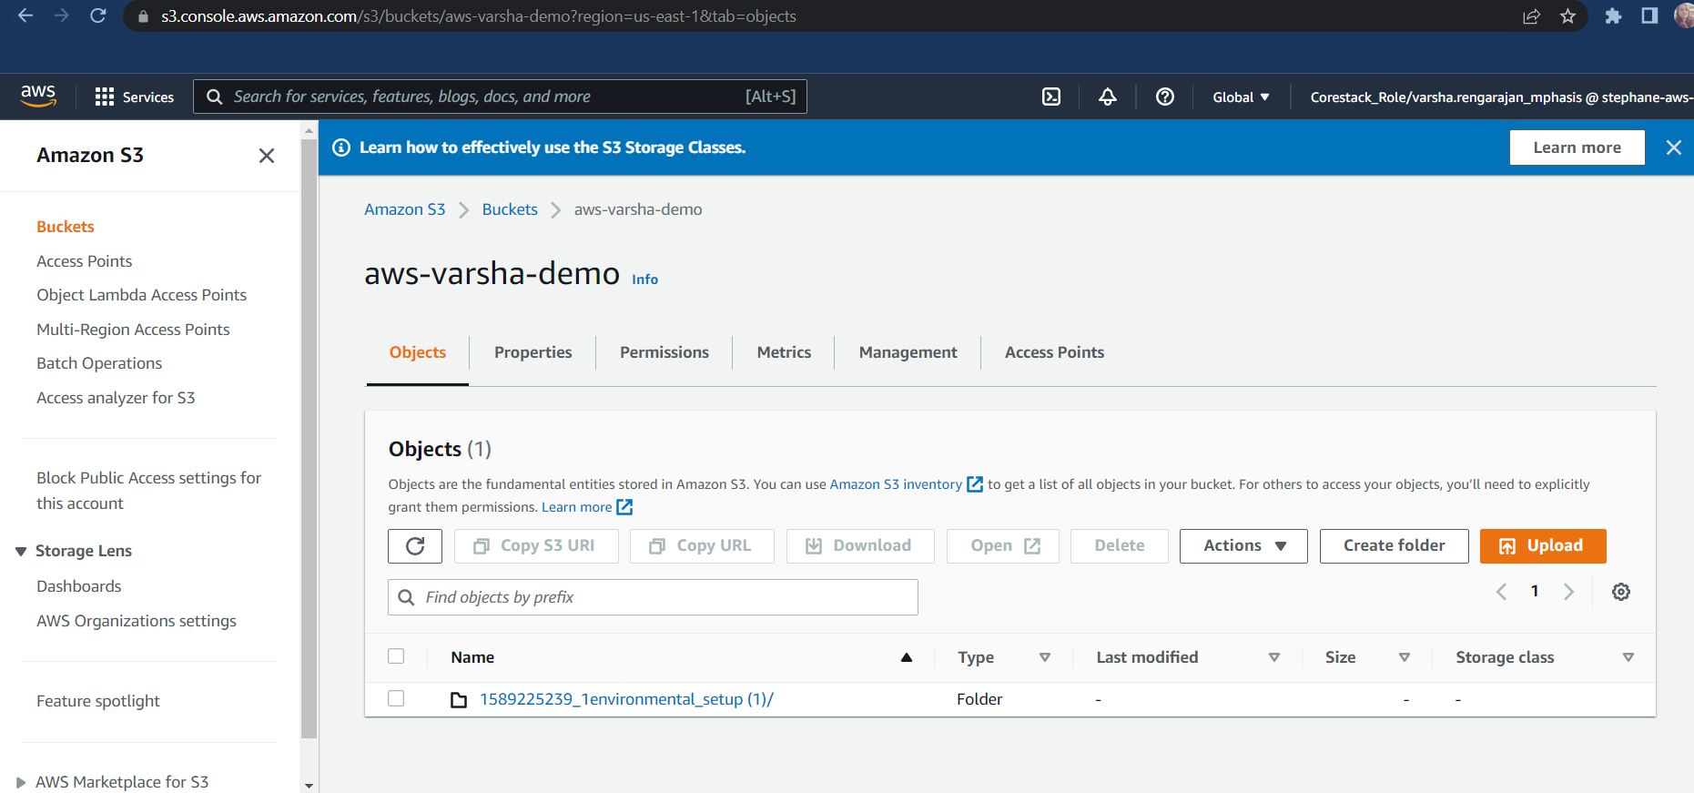

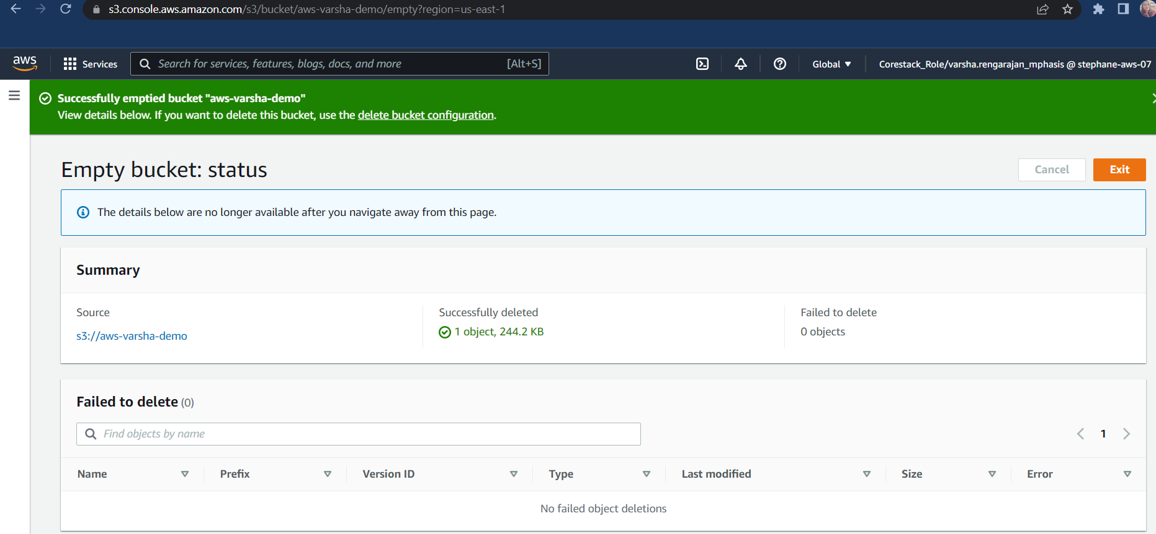EMPTY A BUCKET

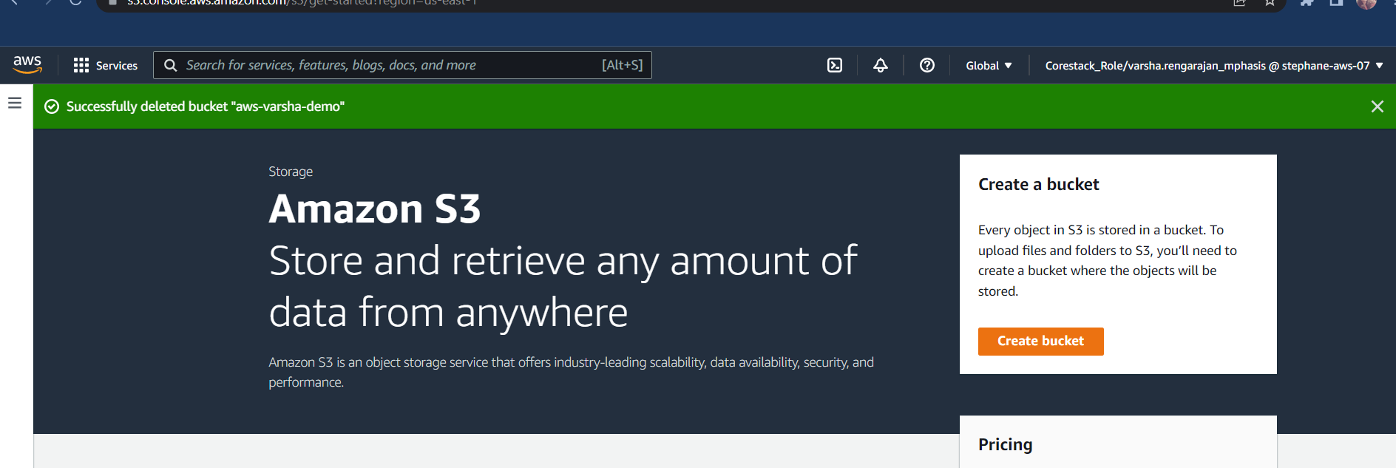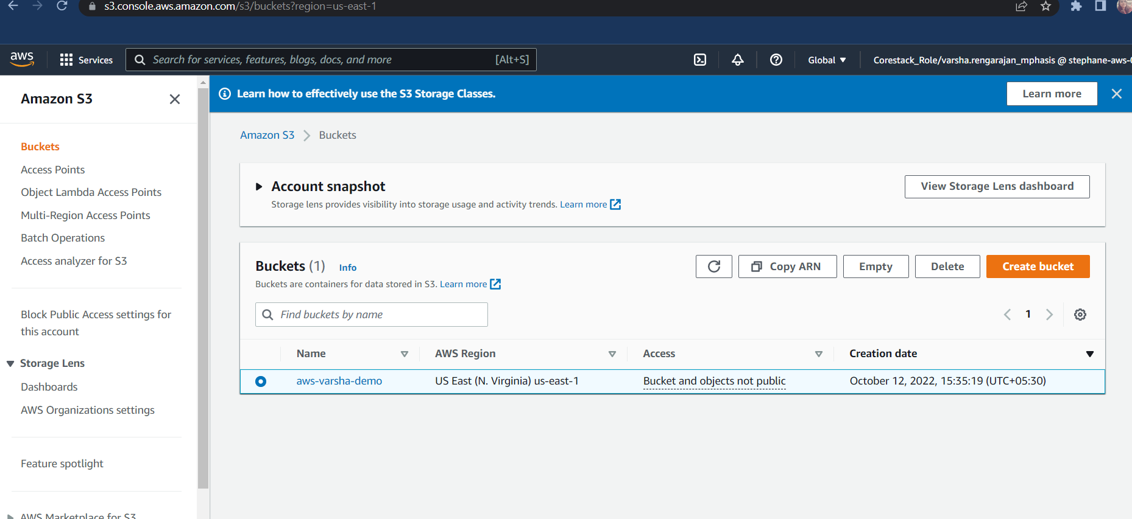DELETE THE BUCKET

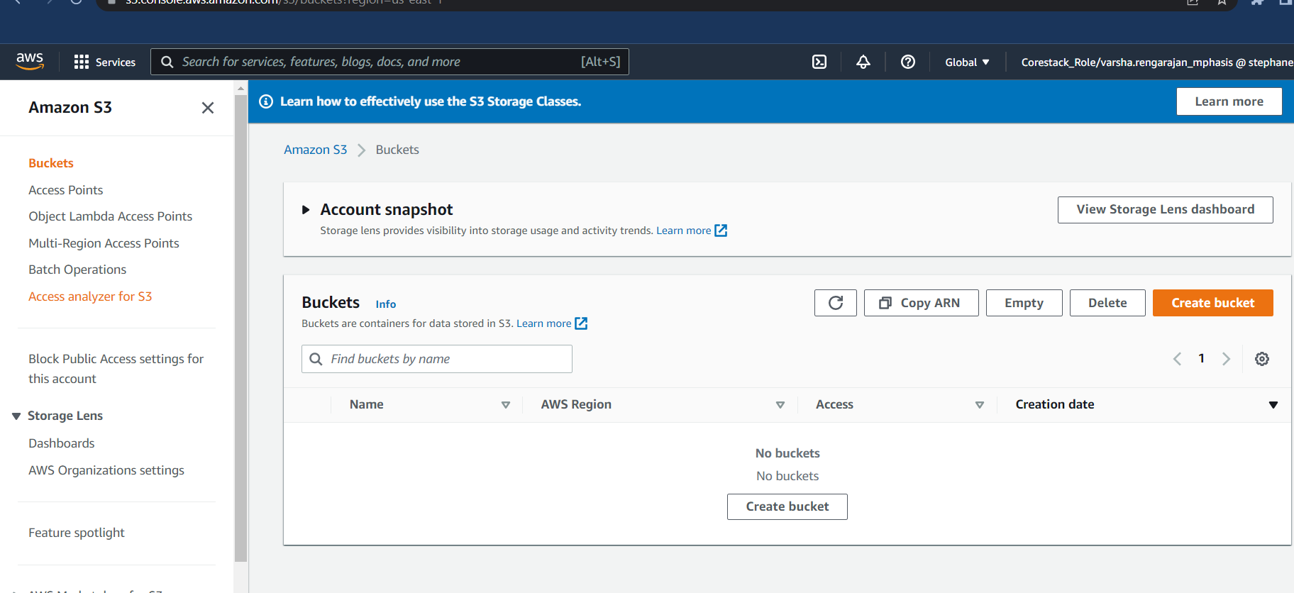THE BUCKET IS DELETED

EBS SNAPSHOT

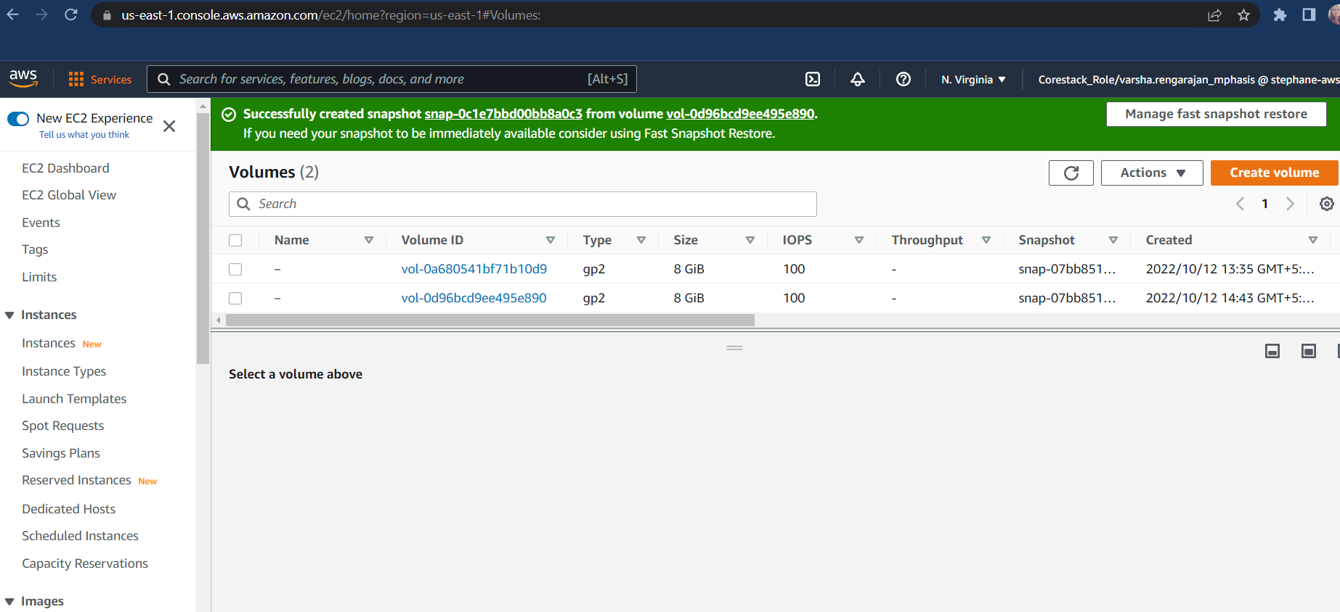

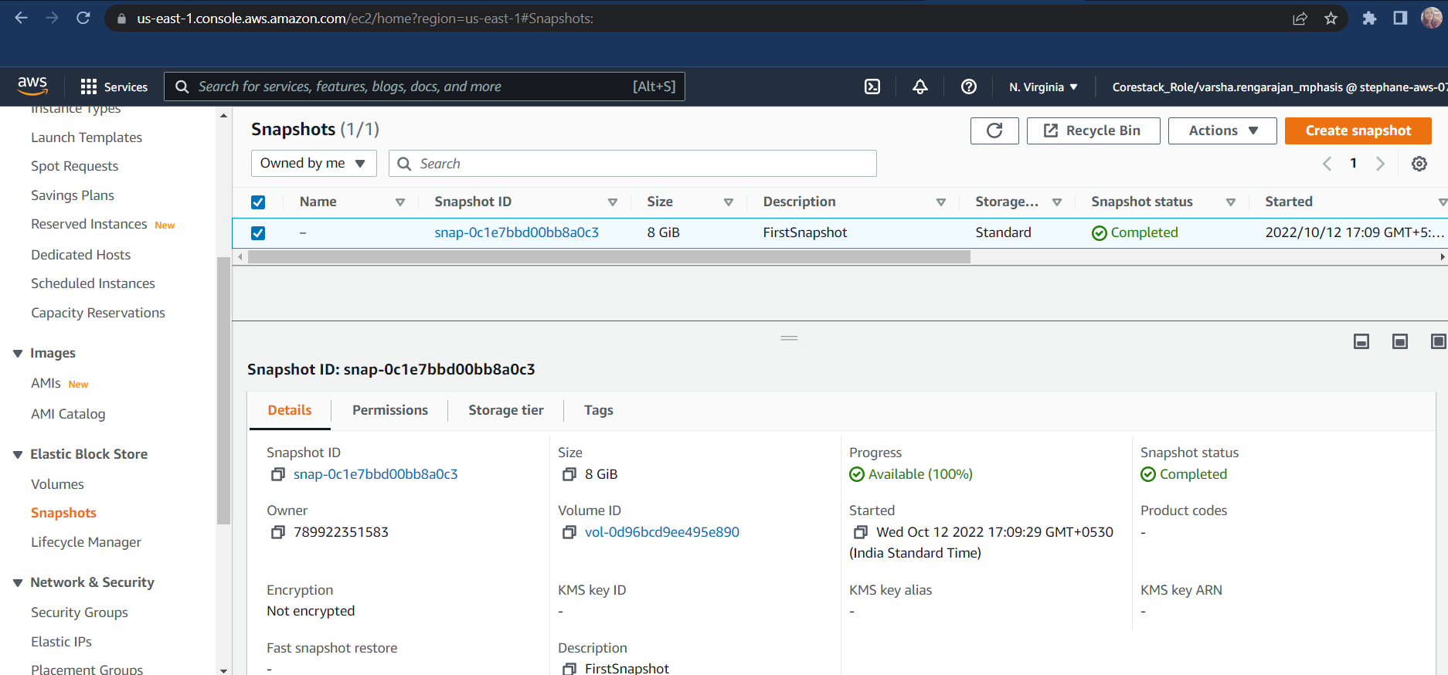

CREATE A IAM USER

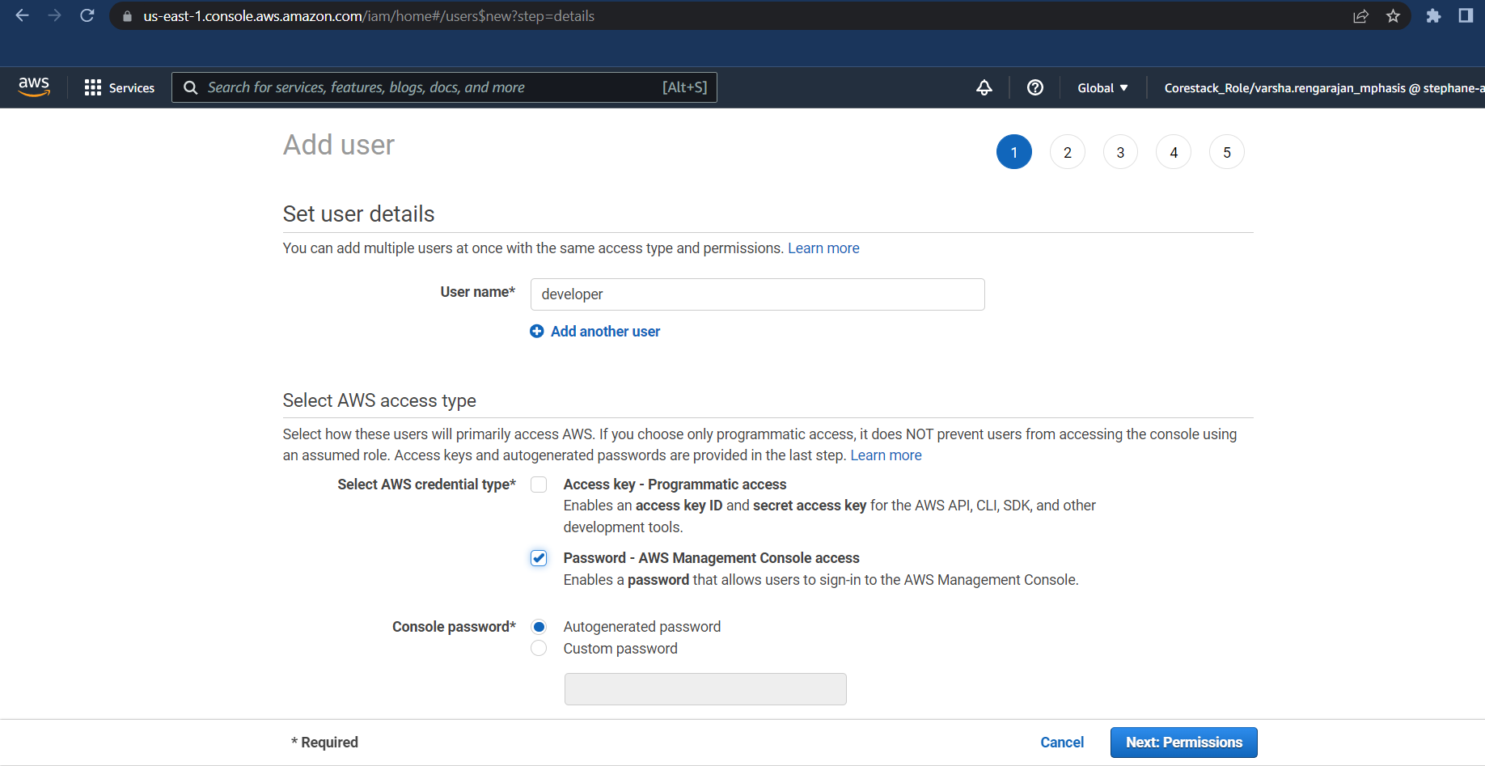

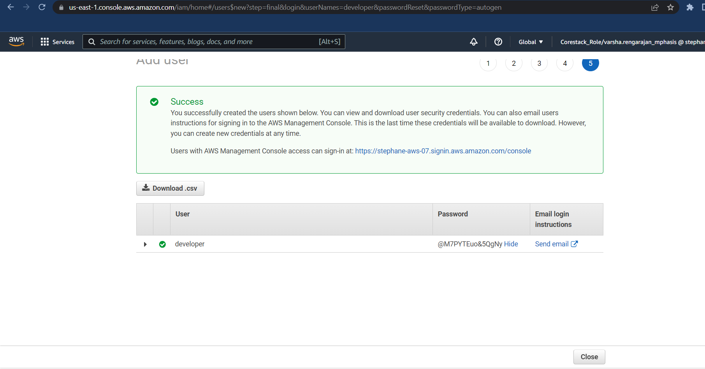

CREATE A IAM GROUP

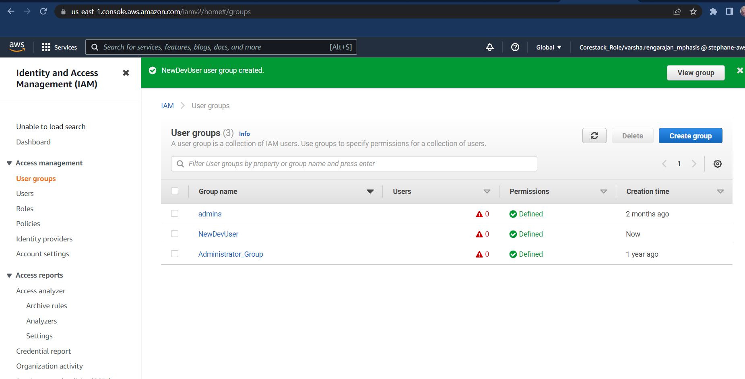

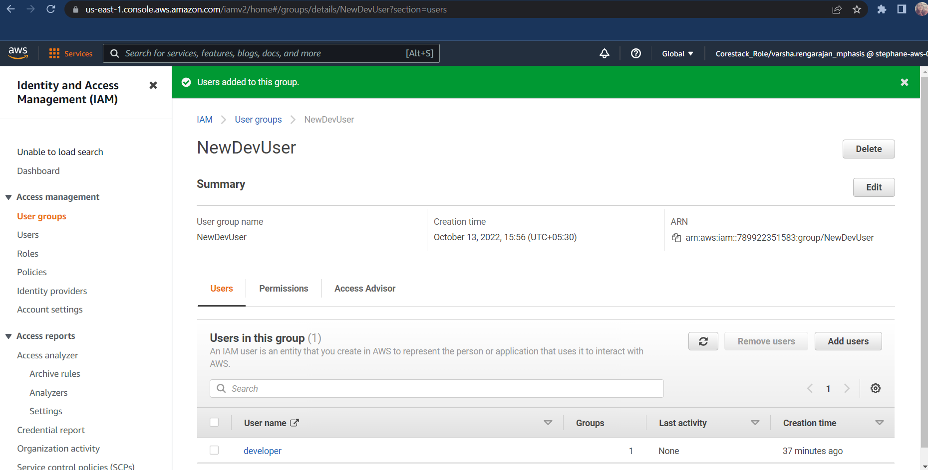

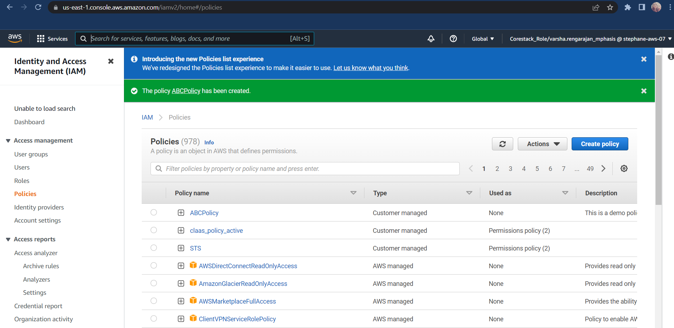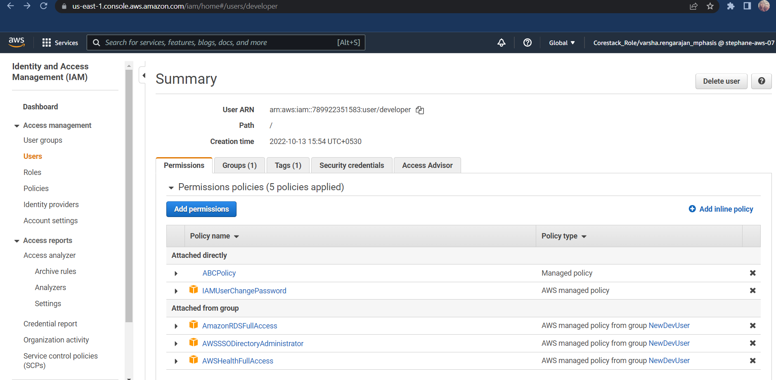POLICY ADDED TO THE GROUP